Test Case: runTestMultipleTimes
Step 1 - Enter username and password and click to button Enter : Credentials Entered
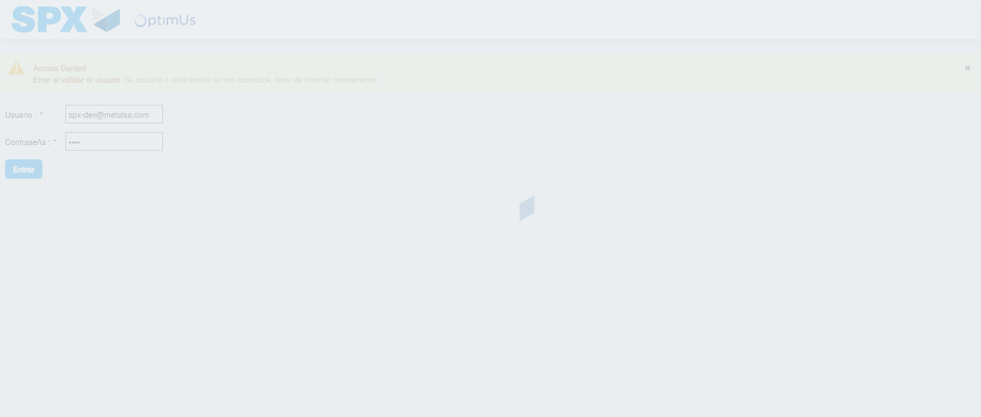Image file-name: QC_Testing-runTestMultipleTimes-nov. 25 2025, 02 11 45 p. m.

Step 2 - Select to UEN and Access to Spot Buy Requisitions : UEN Correctly selected and Correct access
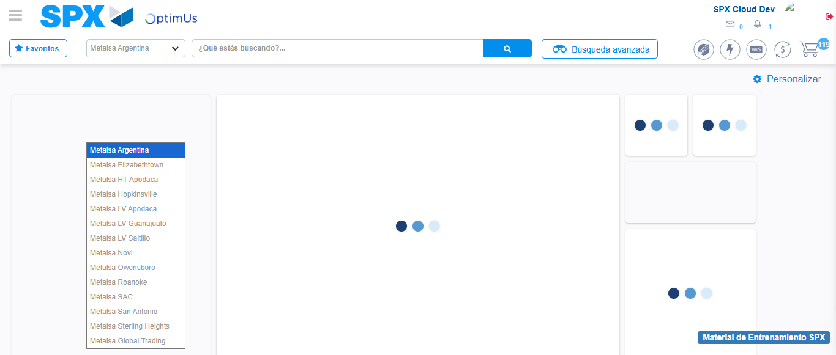Image file-name: QC_Testing-runTestMultipleTimes-nov. 25 2025, 02 11 48 p. m.

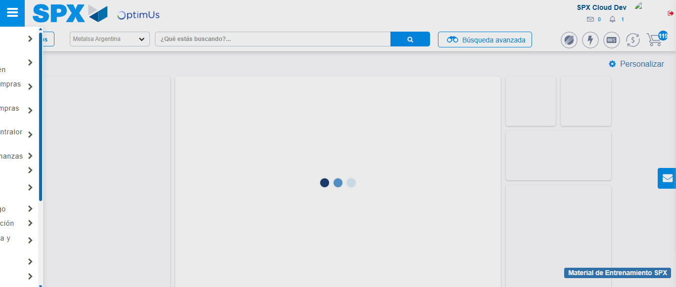Image file-name: QC_Testing-runTestMultipleTimes-nov. 25 2025, 02 11 49 p. m.

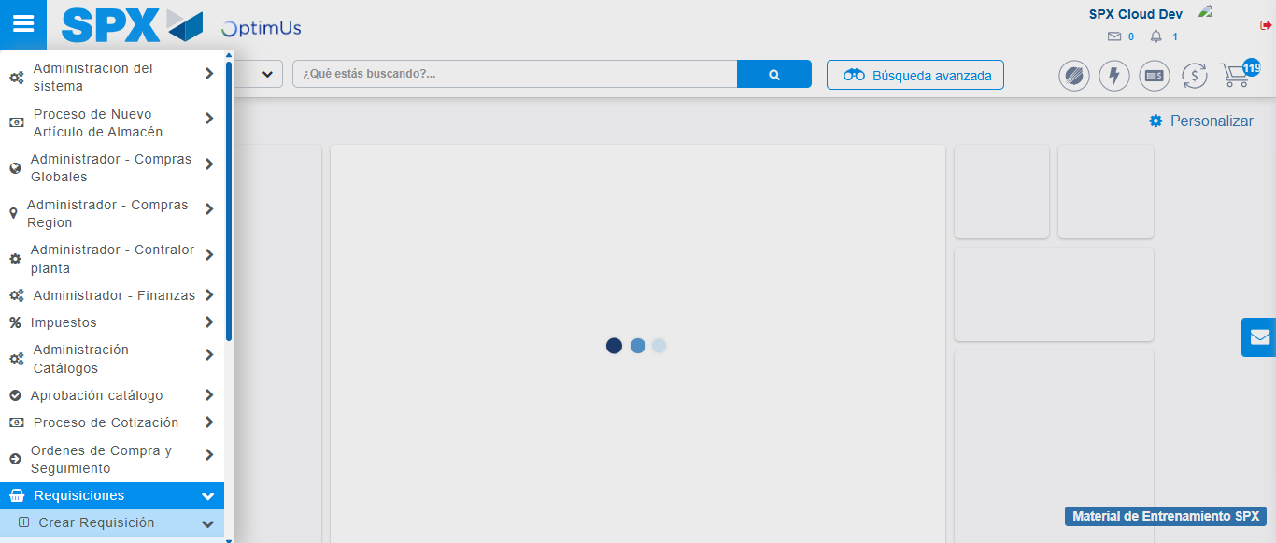Image file-name: QC_Testing-runTestMultipleTimes-nov. 25 2025, 02 11 50 p. m.

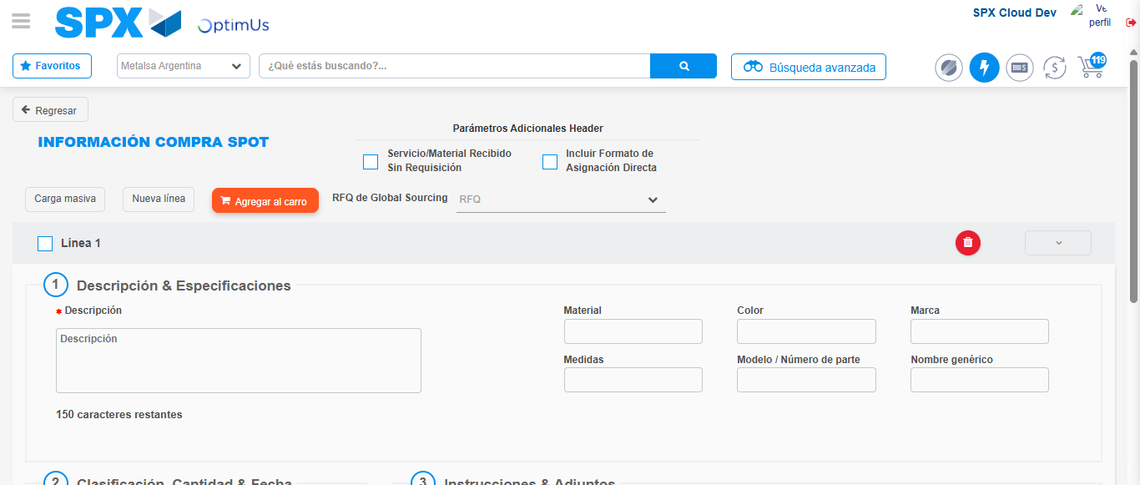Image file-name: QC_Testing-runTestMultipleTimes-nov. 25 2025, 02 11 55 p. m.

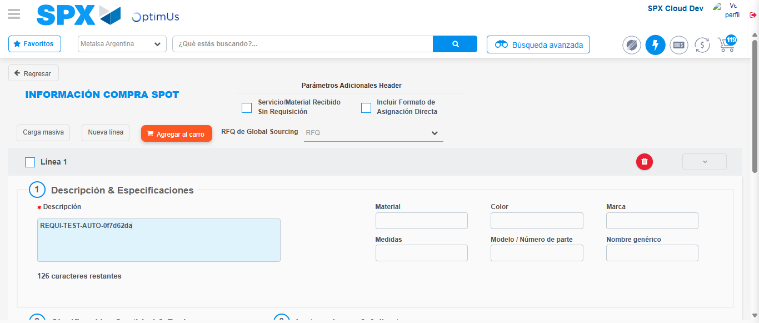Image file-name: QC_Testing-runTestMultipleTimes-nov. 25 2025, 02 11 56 p. m.

Step 3 - Data Capture Spot Buy Requisition : Data captured correctly
Image file-name: QC_Testing-runTestMultipleTimes-nov. 25 2025, 02 11 56 p. m.

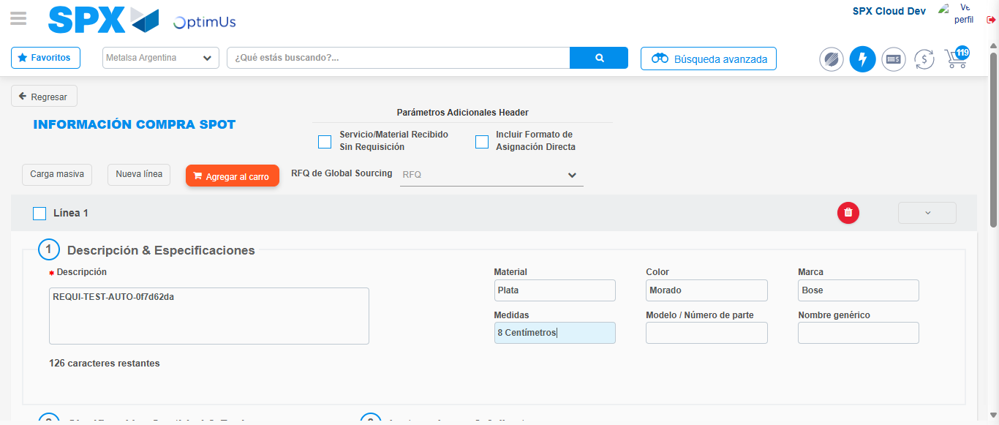Image file-name: QC_Testing-runTestMultipleTimes-nov. 25 2025, 02 11 57 p. m.

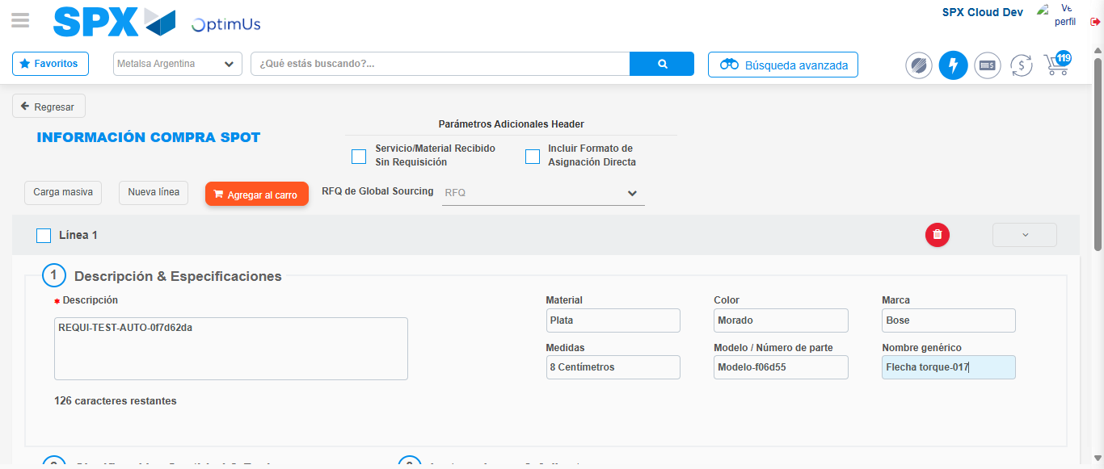Image file-name: QC_Testing-runTestMultipleTimes-nov. 25 2025, 02 11 58 p. m.

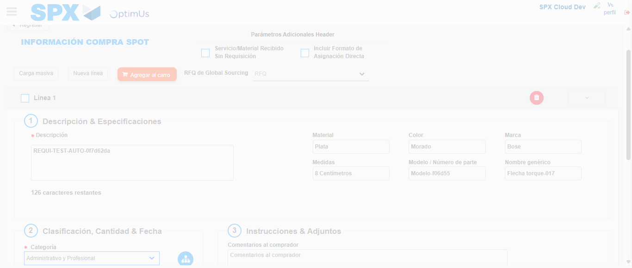Image file-name: QC_Testing-runTestMultipleTimes-nov. 25 2025, 02 11 59 p. m.

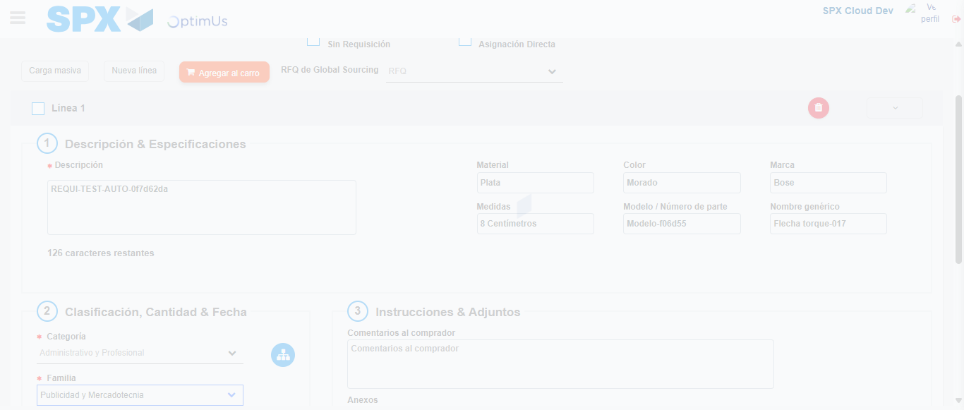Image file-name: QC_Testing-runTestMultipleTimes-nov. 25 2025, 02 12 00 p. m.

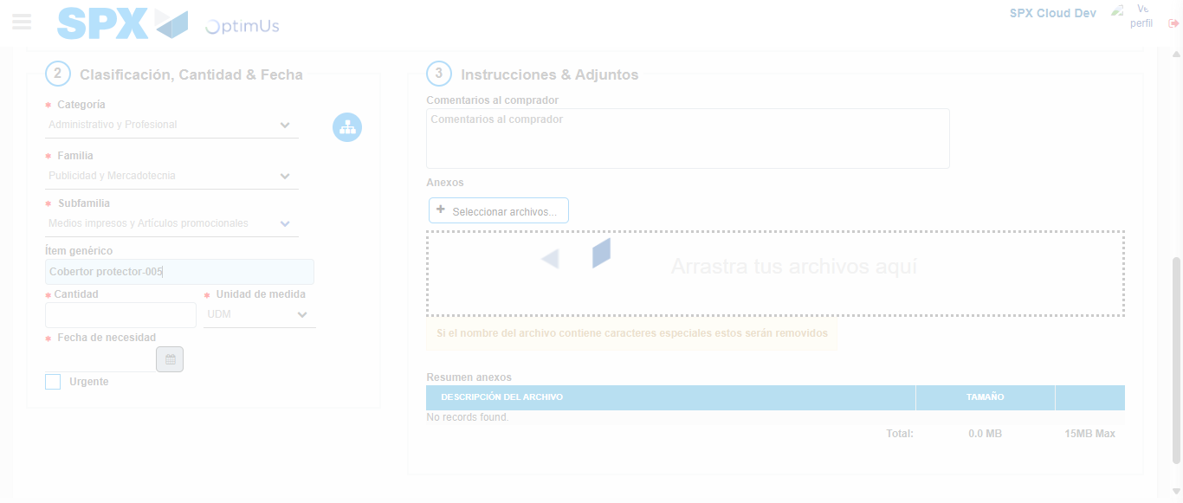Image file-name: QC_Testing-runTestMultipleTimes-nov. 25 2025, 02 12 01 p. m.

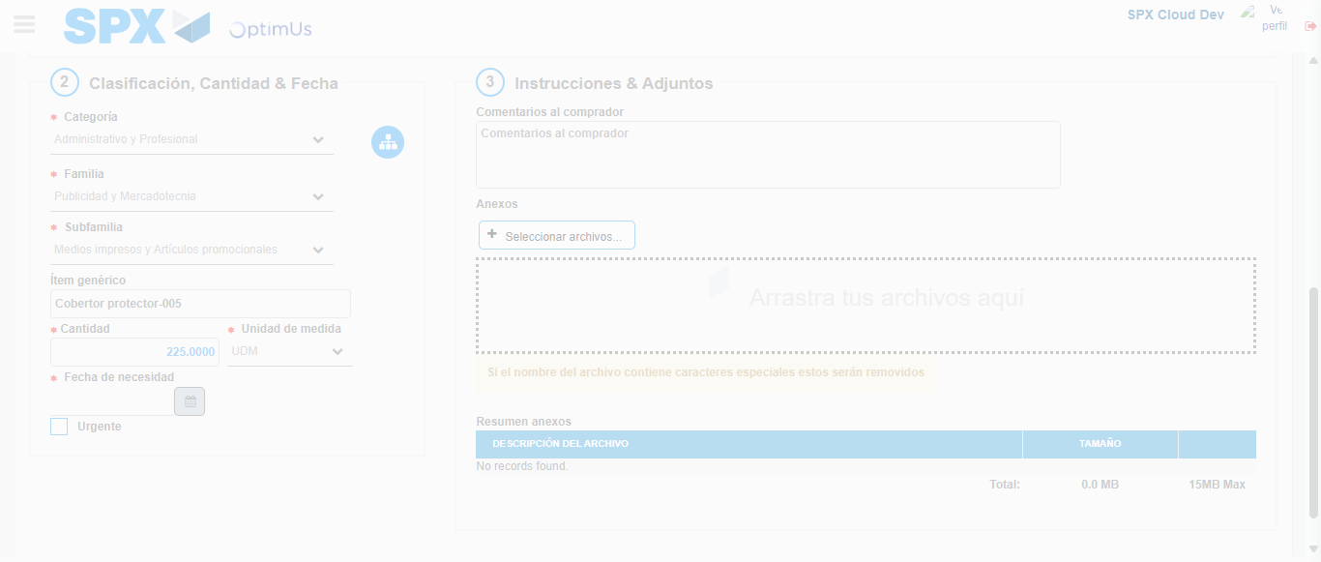Image file-name: QC_Testing-runTestMultipleTimes-nov. 25 2025, 02 12 02 p. m.

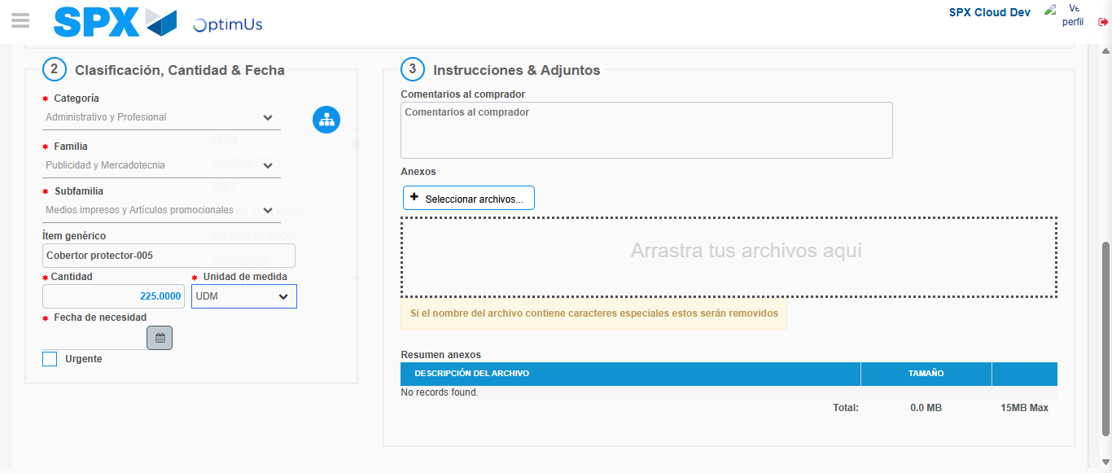Image file-name: QC_Testing-runTestMultipleTimes-nov. 25 2025, 02 12 05 p. m.

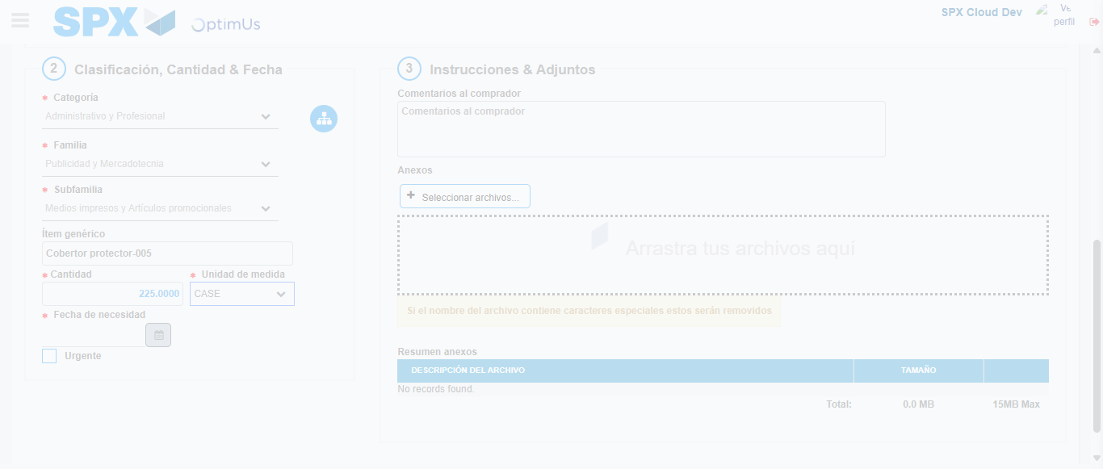Image file-name: QC_Testing-runTestMultipleTimes-nov. 25 2025, 02 12 06 p. m.

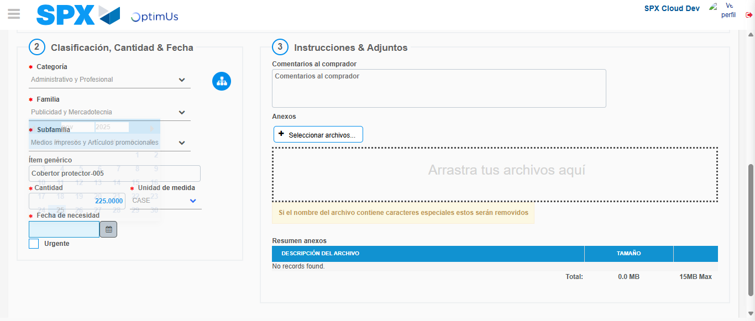Image file-name: QC_Testing-runTestMultipleTimes-nov. 25 2025, 02 12 09 p. m.

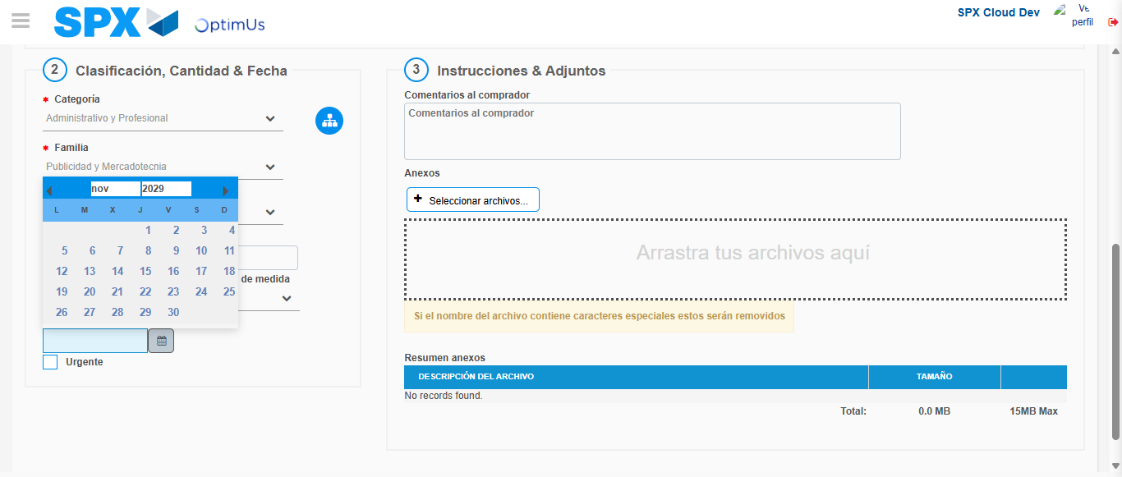Image file-name: QC_Testing-runTestMultipleTimes-nov. 25 2025, 02 12 10 p. m.

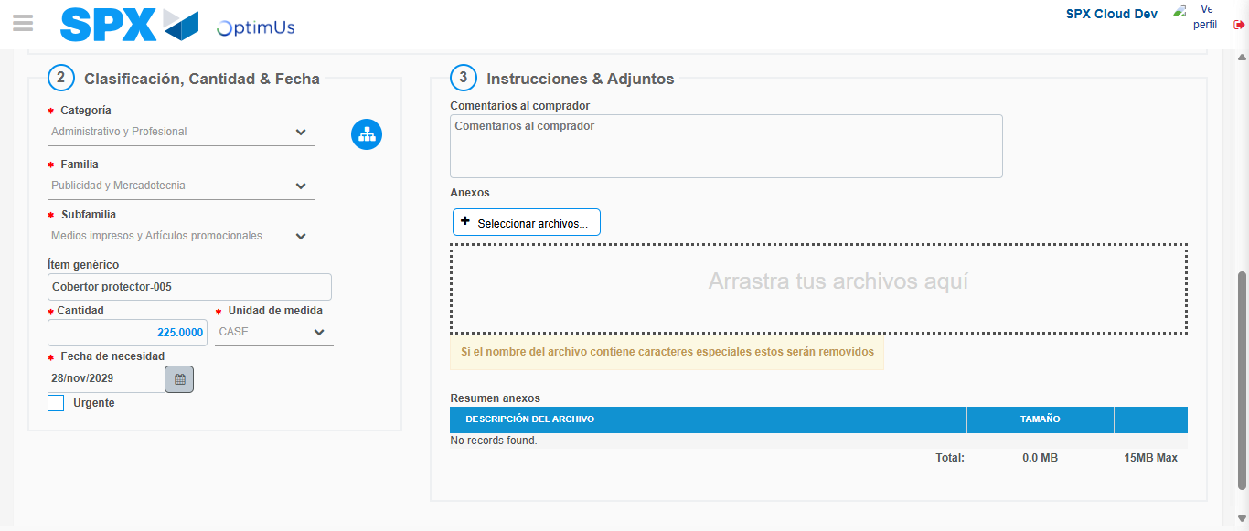Image file-name: QC_Testing-runTestMultipleTimes-nov. 25 2025, 02 12 11 p. m.

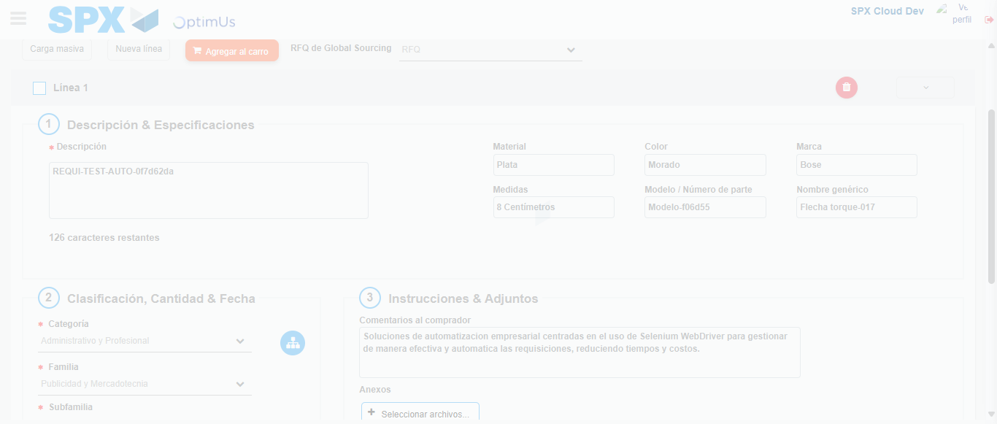Image file-name: QC_Testing-runTestMultipleTimes-nov. 25 2025, 02 12 12 p. m.

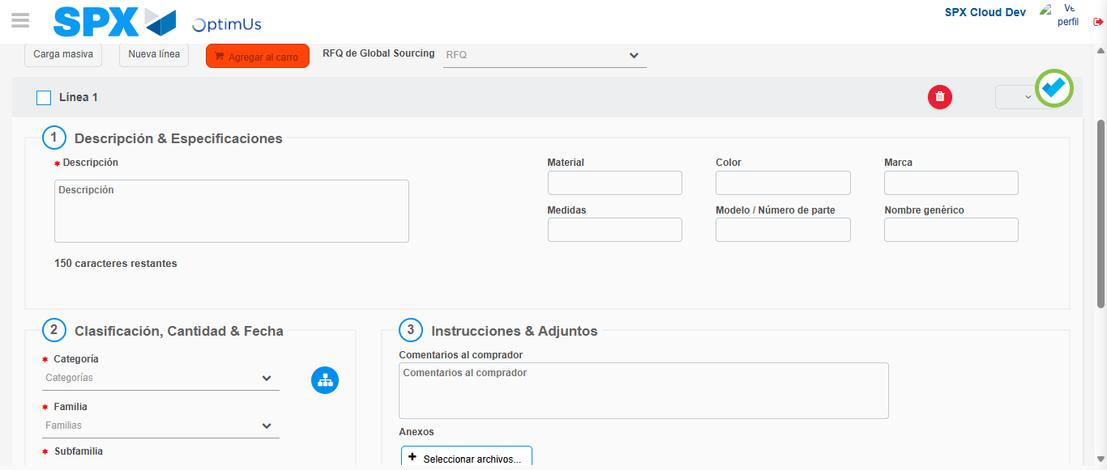Image file-name: QC_Testing-runTestMultipleTimes-nov. 25 2025, 02 12 15 p. m.

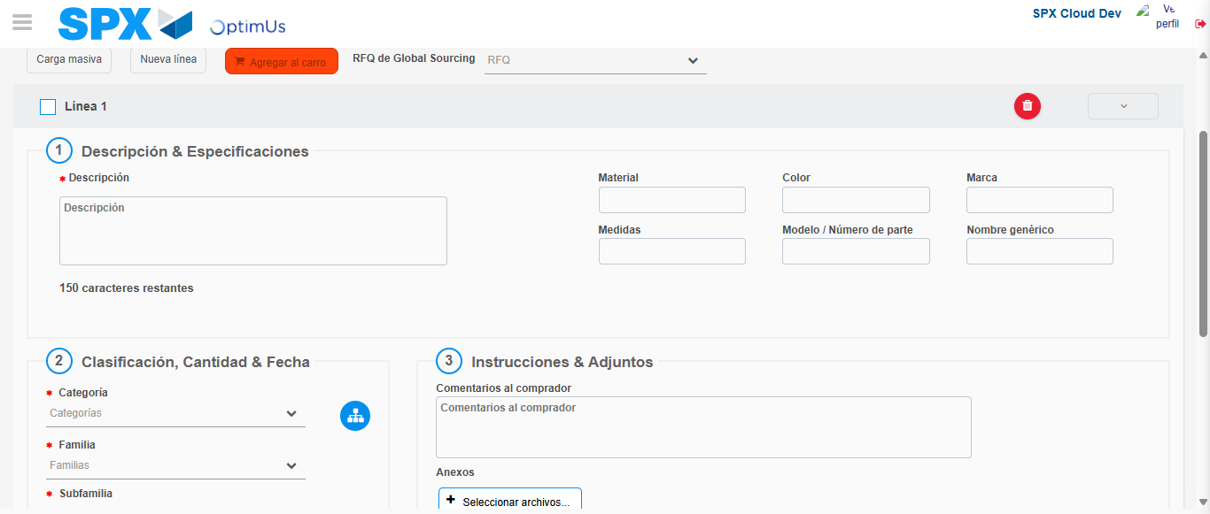Image file-name: QC_Testing-runTestMultipleTimes-nov. 25 2025, 02 12 16 p. m.

Step 4 - Select to Requisition : Requisition Correctly selected
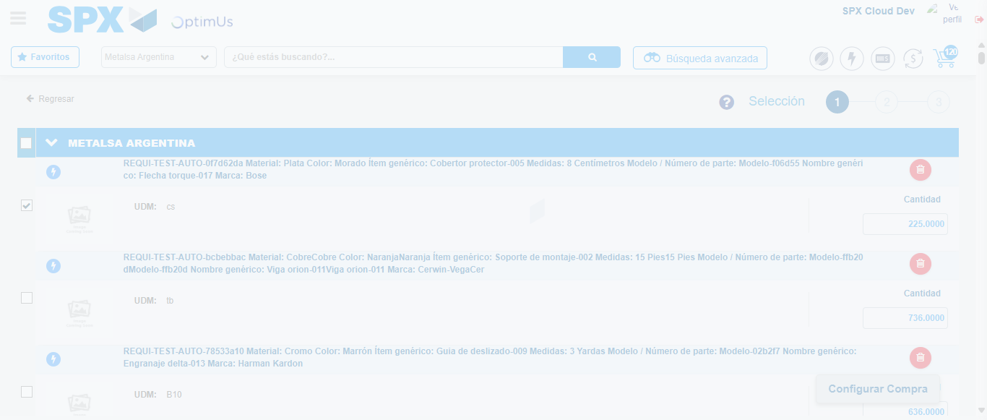Image file-name: QC_Testing-runTestMultipleTimes-nov. 25 2025, 02 12 24 p. m.

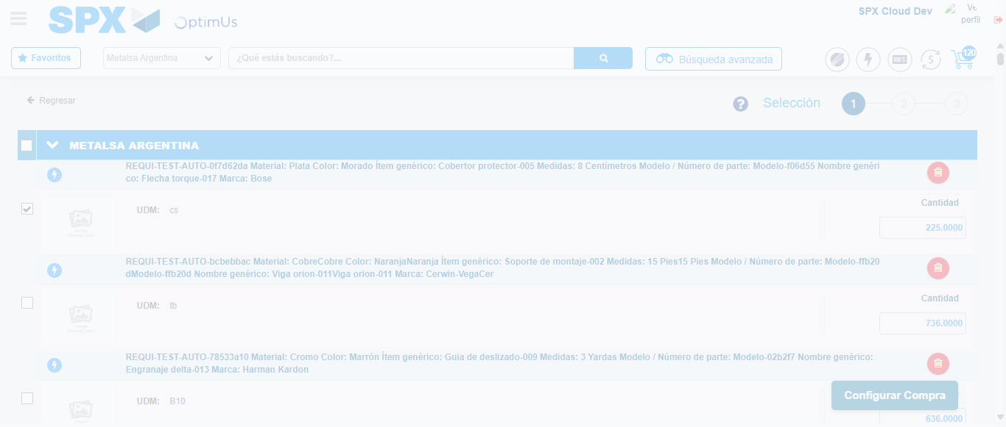Image file-name: QC_Testing-runTestMultipleTimes-nov. 25 2025, 02 12 28 p. m.

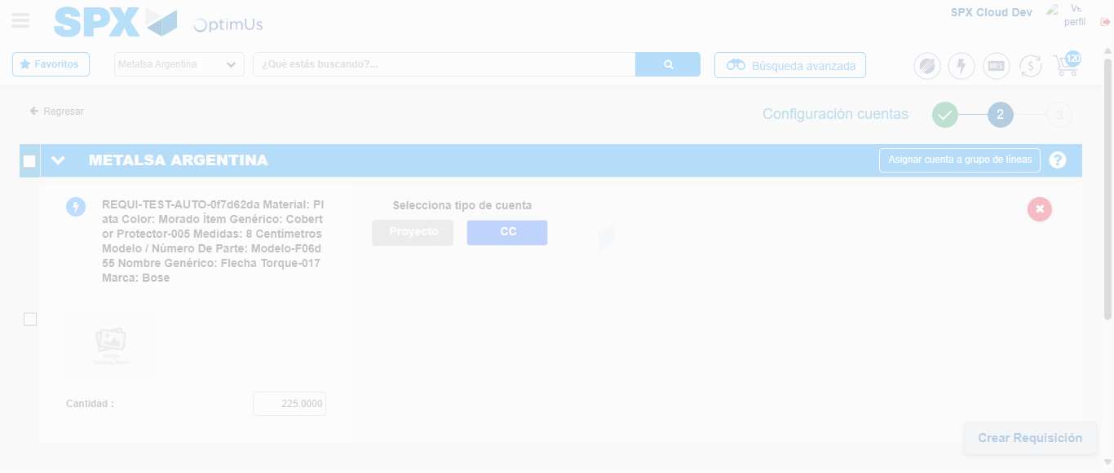Image file-name: QC_Testing-runTestMultipleTimes-nov. 25 2025, 02 12 31 p. m.

Step 5 - Select Type Account For Requisition : Type Account Correctly selected
Image file-name: QC_Testing-runTestMultipleTimes-nov. 25 2025, 02 12 31 p. m.

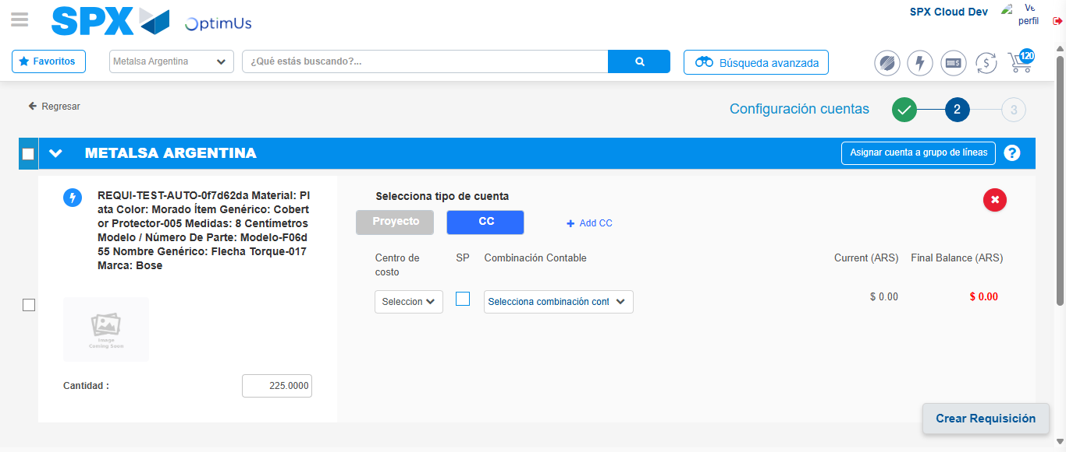Image file-name: QC_Testing-runTestMultipleTimes-nov. 25 2025, 02 12 34 p. m.

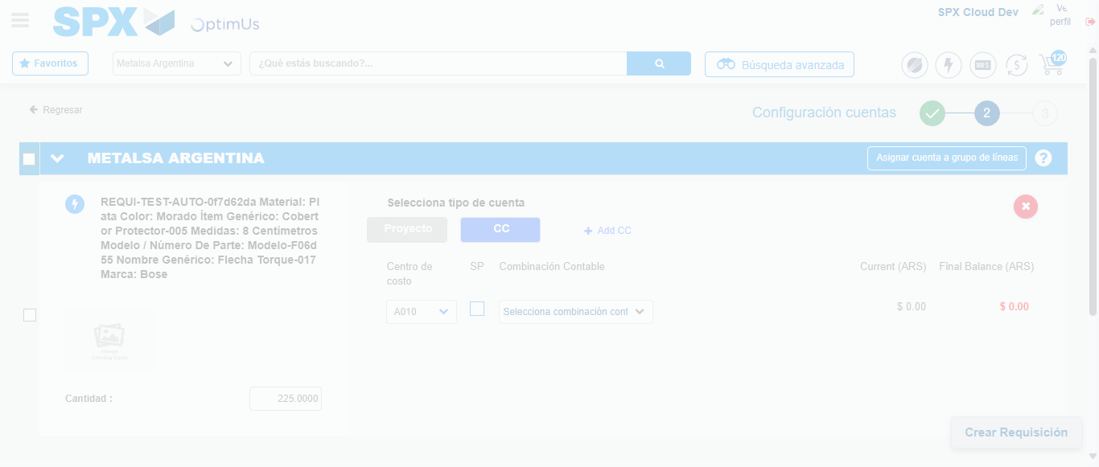Image file-name: QC_Testing-runTestMultipleTimes-nov. 25 2025, 02 12 38 p. m.

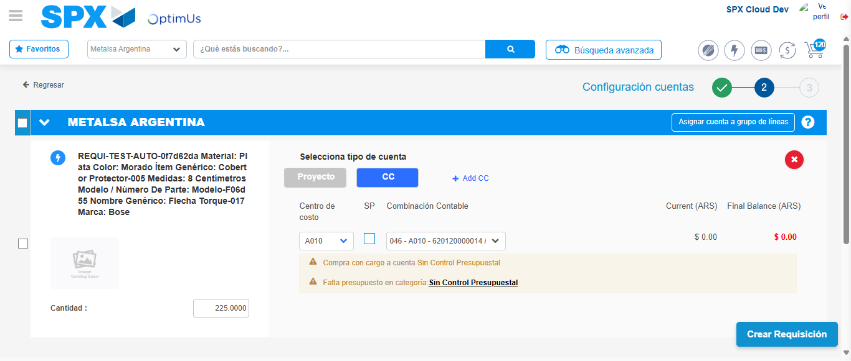Image file-name: QC_Testing-runTestMultipleTimes-nov. 25 2025, 02 12 41 p. m.

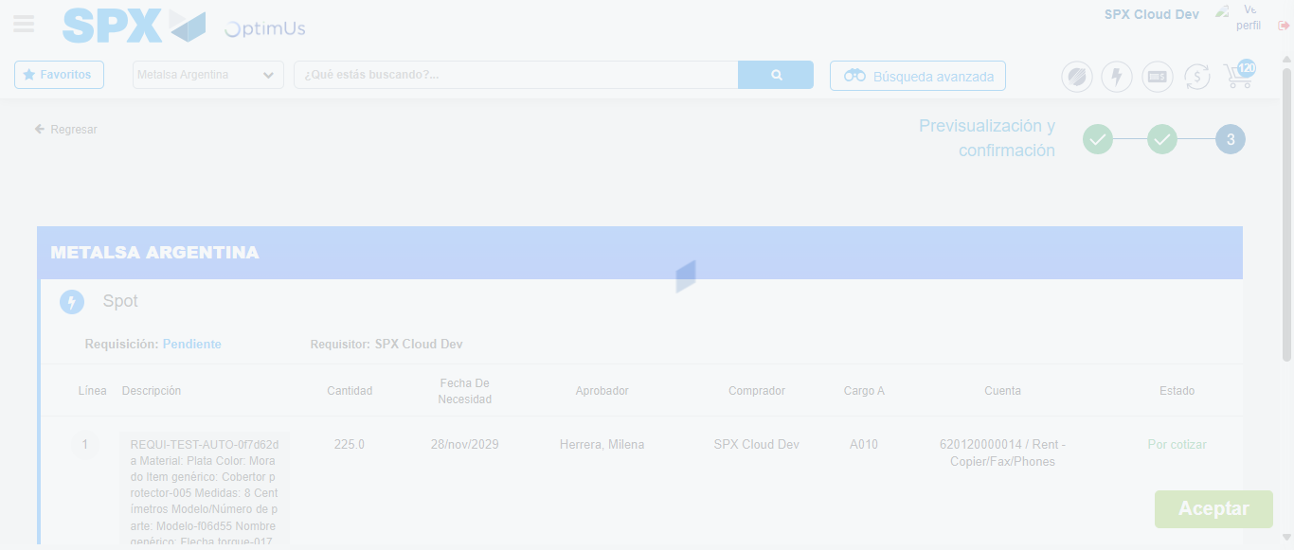Image file-name: QC_Testing-runTestMultipleTimes-nov. 25 2025, 02 12 42 p. m.

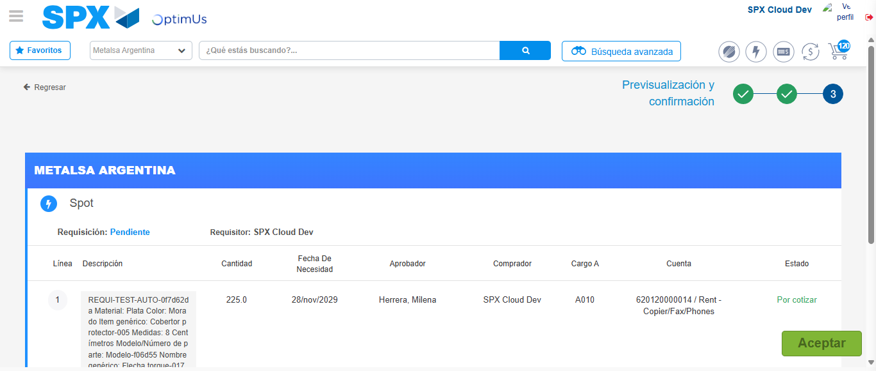Image file-name: QC_Testing-runTestMultipleTimes-nov. 25 2025, 02 12 45 p. m.

Step 6 - Accept to Requisition : Requisition Accepted
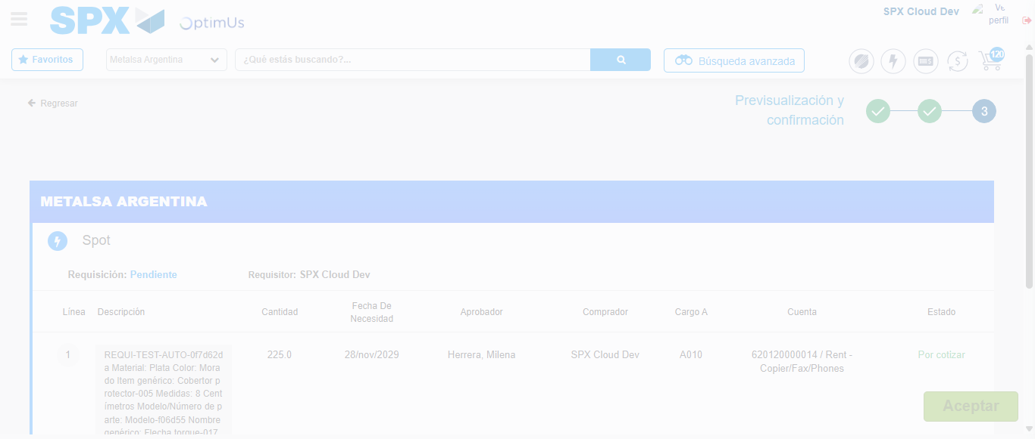Image file-name: QC_Testing-runTestMultipleTimes-nov. 25 2025, 02 12 46 p. m.

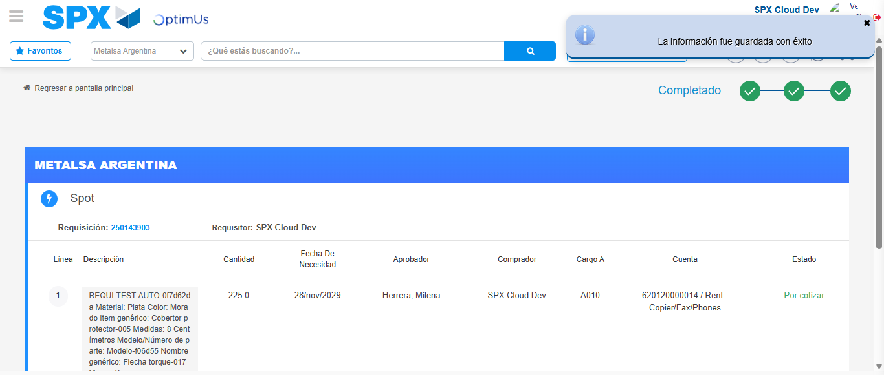Image file-name: QC_Testing-runTestMultipleTimes-nov. 25 2025, 02 12 49 p. m.

